A U D I T F L O W
Technical & Operations Manual
Screen-by-screen reference: routes, APIs, database tables, and troubleshooting

Developed by RvTech Solutions Pvt. Ltd.
Internal reference — not for end-user distribution
Frontend: React 19 + Vite SPA · Backend: .NET 8 Clean Architecture
Synced against frontend main / backend commit as of August 14, 2026 — re-verify against current code for anything load-bearing

© 2026 RvTech Solutions Pvt. Ltd. — All rights reserved.

Table of Contents
This list updates automatically when the document is opened in Microsoft Word. If page numbers don't appear, right-click anywhere in the list and choose “Update Field.”

1. Purpose of this document
A single reference for tracing a screen in the AuditFlow app back to the exact API endpoint(s) and database table(s) behind it — so a user-reported issue ("why does this task show the wrong status", "why can't this person see this report") can be chased straight to a SQL query or a log line instead of re-reading the codebase from scratch each time.
Note: This is a snapshot, not a live source. Two repos evolve together — verify against current code before trusting a detail here for anything load-bearing. The frontend repo's own PROJECT_CONTEXT.md and ARCHITECTURE.md, and the backend repo's DatabaseStructure.md / ArchitectureFlow.md / AuditSummary.md, are the deeper, continuously-maintained versions of what's summarized here.

2. Architecture at a glance

2.1 Two repos, developed together
Repo | Path | Stack
Frontend | AuditFlow-Frontend\AuditFlow-Frontend | React 19 + Vite 6 SPA, TanStack Query, react-router-dom 7, hand-rolled fetch wrapper (no axios)
Backend | AuditFlow-Backend\AuditFlow-Backend\AuditFlow-Backend | .NET 8, Clean Architecture (5 projects), EF Core 8 / SQL Server, MediatR (CQRS), ASP.NET Identity, Hangfire, SignalR, Serilog
Note: The frontend has dead Next.js scaffold files (next.config.js, app/, src/App.jsx, src/main.jsx, vite.config.js, tailwind.config.js) left over from an abandoned first approach — the real entry point is src/main.tsx. Never edit or build against the Next.js files.

2.2 The tenancy hierarchy
Everything hangs off one chain: Tenant (an audit firm's account — called "Auditor Account" in the Platform admin UI) → Company (one of that firm's clients) → SubCompany (an optional division/region) → Users. Almost every other table (Tasks, Comments, Attachments, Notifications, AuditLogs, Reports, Invitations, Announcements, UserCompanyMappings) carries its own TenantId and is filtered by it automatically on every query — see §2.4.

2.3 Request flow
Browser → src/lib/apiClient.ts (attaches JWT bearer, single-flight refresh on 401, unwraps the ApiResponse envelope) → ASP.NET [Authorize(Roles="...")] on the controller action (role check only — returns an empty-body 401/403 before ever reaching application code if it fails) → MediatR command/query handler → EF Core (ApplicationDbContext) → SQL Server.
Pipeline behaviors wrap every MediatR handler in order: ValidationBehavior (FluentValidation) → LoggingBehavior → PerformanceBehavior (logs a warning if a handler takes over 500ms).

2.4 Multi-tenancy — two enforcement layers
1. Global EF query filter — ApplicationDbContext.OnModelCreating attaches !IsDeleted && TenantId == <caller's tenant> to nearly every entity. This runs automatically on every LINQ query; a handler can't leak another tenant's rows just by forgetting a .Where(). AuditLogs and TaskStatusHistories deliberately skip the IsDeleted half (they're permanent audit trails).
2. ITenantScopeService (Application layer, not an ASP.NET policy) — adds company/assignee-level narrowing on top of the tenant filter: GetEnforcedCompanyId()/GetEnforcedCompanyIds() for Company admin/Employee's own company or an Auditor's mapped companies (UserCompanyMappings), GetEnforcedAssigneeId() for an Employee's own tasks. A client-supplied companyId/assigneeId is silently overridden (not just validated) for these roles — they always get their own scoped data.
Note: A mapped Auditor (has ≥1 UserCompanyMapping row) is restricted to those companies; an unmapped Auditor falls through to unrestricted-within-tenant. This is a real, load-bearing distinction when diagnosing "why can't this Auditor see company X" — check UserCompanyMappings first.

2.5 Auth model
- JWT Bearer, 60-minute access token, 7-day refresh token (SHA-256-hashed at rest, rotated on every use, reuse-detection revokes every session for that user on replay).
- Real TOTP MFA (RFC 6238), with recovery codes. Lockout after 5 failed attempts / 15 minutes.
- JWT claims: nameidentifier (= Users.Id), role (string, e.g. "Auditor" — sourced from AspNetUserRoles, not Users.Role directly, see §5.7), tenant_id, company_id/sub_company_id (Company admin/Employee only), mapped_company_id (repeated per UserCompanyMapping row, for a scoped Auditor).
- Authorization is [Authorize(Roles=...)] attribute-based only — no custom policy handlers. Row/data-level scoping lives entirely in ITenantScopeService + the EF global filter (§2.4), not in the attribute.

3. Running everything locally

3.1 Backend
cd AuditFlow-Backend\AuditFlow-Backend\AuditFlow-Backend
dotnet run --project src/AuditFlow.API --urls http://localhost:5298
- Health check: GET http://localhost:5298/health (~10–12s cold start)
- Swagger (dev only): http://localhost:5298/
- Database: local SQL Server, Windows auth, database name AuditFlow. Apply migrations: dotnet ef database update --project src/AuditFlow.Infrastructure --startup-project src/AuditFlow.API
- Dev email (no real SMTP in dev) → written as .html/.eml files to C:\AuditFlow\EmailPickup\
- Dev file storage (attachments/report exports) → C:\AuditFlow\FileStorage
- Logs (Serilog) → C:\AuditFlow\Logs\

3.2 Frontend
npm install
npm run dev # http://localhost:5173 (or next free port)
npm run build # tsc typecheck, then vite build
VITE_API_MODE in .env.local controls mock vs. live: "mock" runs entirely from src/mock-data/*.ts with no backend needed; "live" talks to VITE_API_BASE_URL (typically http://localhost:5298/api/v1). Every services/*.ts function branches on this flag — never remove the mock path from a function without explicit confirmation.

3.3 Seed / test accounts
One account per role exists in the shared seed tenant, all sharing the same password. See Documents/AuthTestingGuide.md (in this repo) for the exact credentials and a full curl+SQL walkthrough of the auth module — deliberately not duplicated here since that file is the maintained source and already has the password redaction convention this document should follow.
Email | Role
platformadmin@seed.test | Platform admin
auditor@seed.test | Auditor
companyadmin@seed.test | Company admin
employee@seed.test | Employee

4. Screen → endpoint → database map
Every enum crosses the wire as a plain integer — no JsonStringEnumConverter is registered anywhere ({"priority": 3}, not {"priority": "High"}). The frontend's src/lib/*Mapping.ts files are the translation layer; see §5.6 for the full enum-value reference when reading a raw integer straight out of the database.

4.1 Sign in
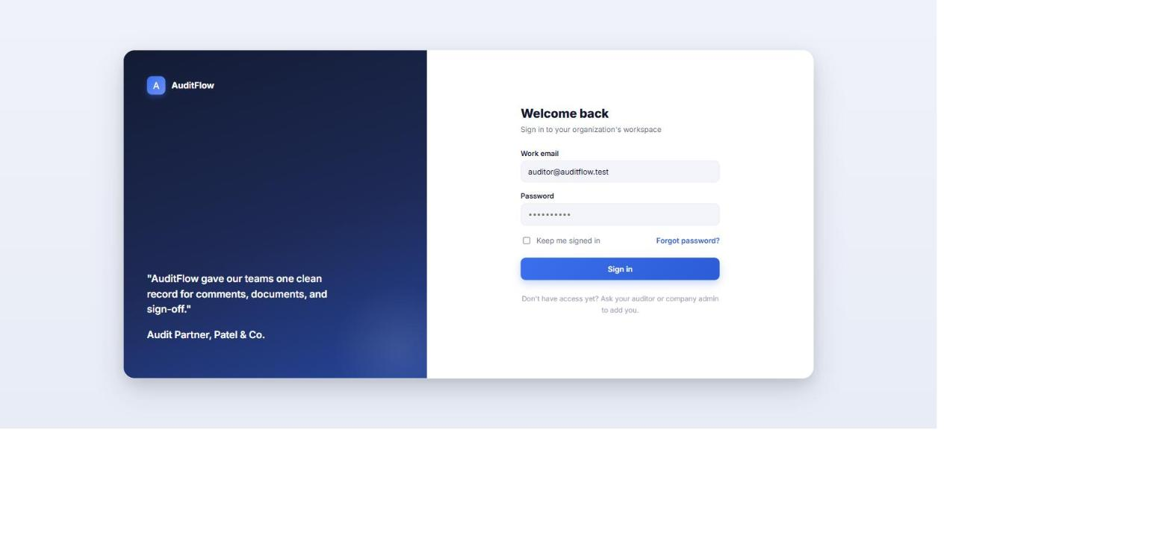
Figure 1 — sign-in screen
Field | Detail
Frontend route | /signin
Key endpoint(s) | POST /api/v1/auth/login
Primary DB table(s) | Users (auth columns), RefreshTokens (issue), AuditLogs (Action=Login, 17)
Note: 401 INVALID_CREDENTIALS covers both "wrong password" and "account doesn't exist" deliberately, to avoid email enumeration. 403 ACCOUNT_NOT_ACTIVE means Users.Status isn't 2 (Active).

4.2 Standard dashboard
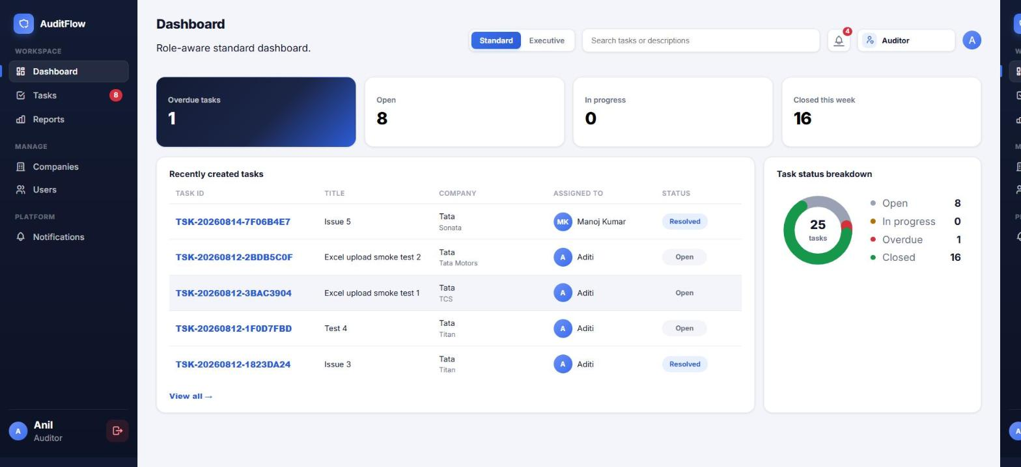
Figure 2 — Standard dashboard
Field | Detail
Frontend route | /dashboard
Key endpoint(s) | GET /dashboard/summary, /dashboard/weekly-tasks, /dashboard/status-breakdown, /dashboard/announcements
Primary DB table(s) | Tasks, Notifications (unread count), Announcements
Note: GetSummaryAsync is cached 60s per-user (IMemoryCache) in DashboardRepository — a status change invalidates it via InvalidateSummaryCache(userId) so the sidebar badge doesn't lag.

4.3 Executive dashboard
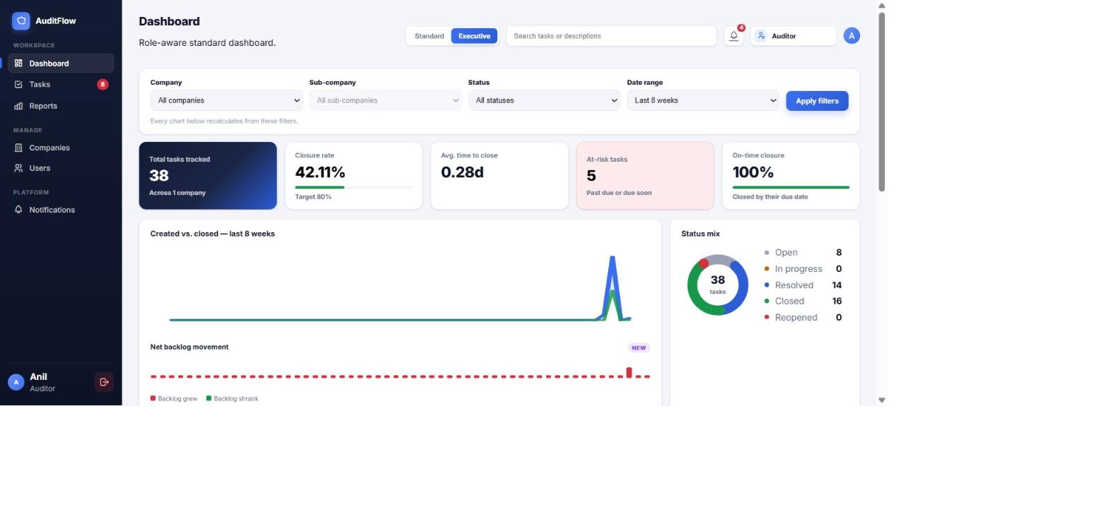
Figure 3 — Executive dashboard
Field | Detail
Frontend route | /dashboard?view=executive
Key endpoint(s) | GET /dashboard/executive/{kpis, trend, status-mix, company-health, risk-tasks, team-workload, aging, reviewer-performance}
Primary DB table(s) | Tasks (all widgets), Users (team workload/reviewer names)
Note: Auditor and Company admin only — [Authorize(Roles="Auditor,CompanyAdmin")] on every executive/* endpoint; Employee never reaches this view even by direct URL (frontend gates it, and the endpoints would 403 anyway). All 8 executive/* queries are now 60s IMemoryCache-cached (added 2026-08-14, see §9).

4.4 Tasks grid
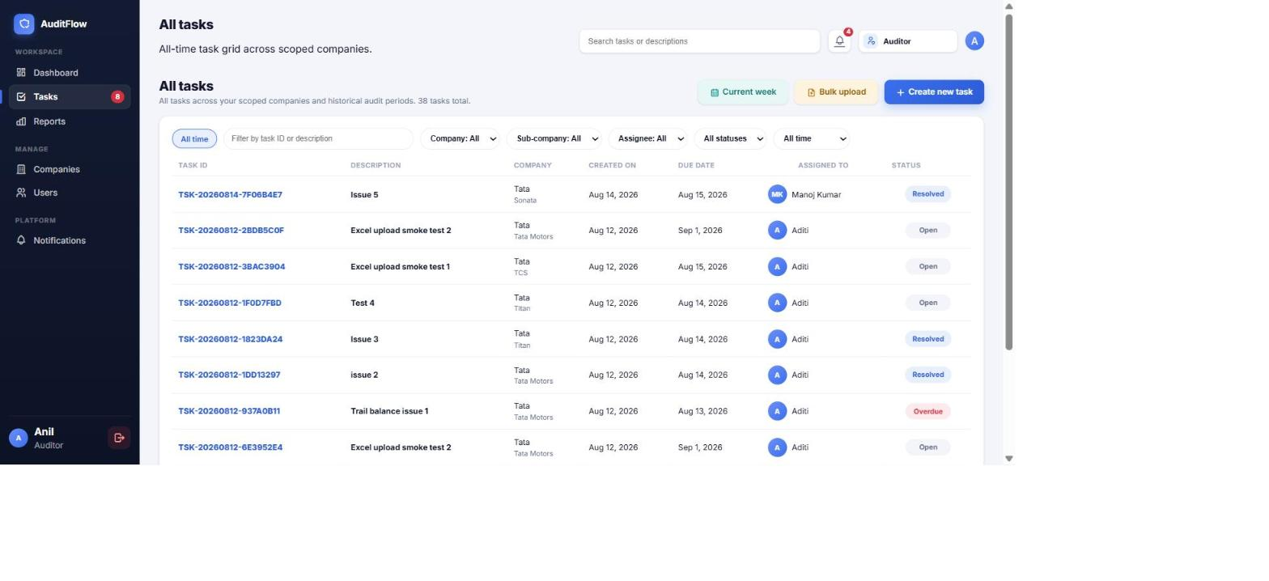
Figure 4 — task grid
Field | Detail
Frontend route | /tasks (week) and /tasks/all
Key endpoint(s) | GET /tasks, GET /tasks/filter-options
Primary DB table(s) | Tasks, Companies, SubCompanies, Users (assignee/filter dropdowns)
Note: TASK_PAGE_SIZE = 10. "Overdue" and "At risk" are client-only pseudo-statuses (see mapTaskStatusEnum / TaskGridPage.tsx) filtered against the already-fetched page, not sent to the backend as a real status param — so Prev/Next still page through the unfiltered result set underneath.

4.5 Create task / Bulk upload
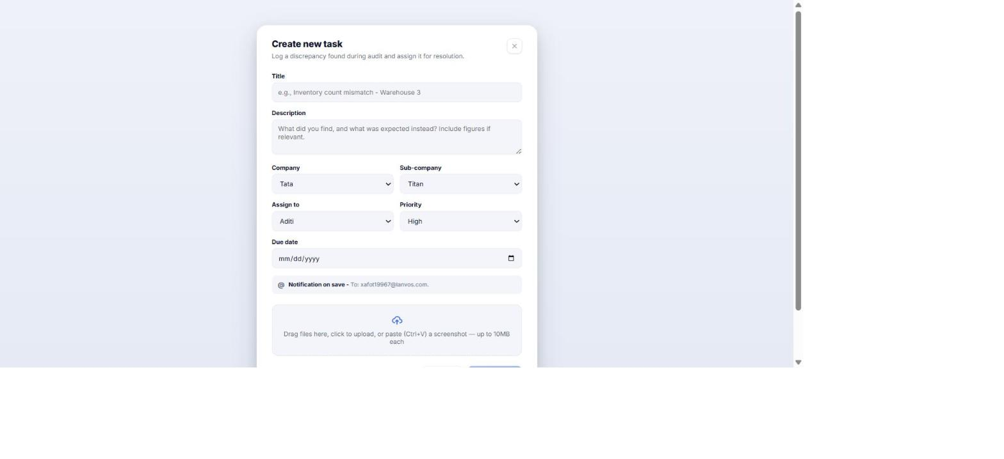
Figure 5 — task creation
Field | Detail
Frontend route | /tasks/new, /tasks/bulk-upload
Key endpoint(s) | POST /tasks, POST /files/upload, POST /tasks/bulk/validate, POST /tasks/bulk/import
Primary DB table(s) | Tasks, Attachments, Notifications (assignee alert), AuditLogs
Note: Auditor-only, enforced both by [Authorize(Roles="Auditor")] and by CreateTaskCommandHandler checking the caller's company scope explicitly (a mapped Auditor can't create a task for a company outside their UserCompanyMapping set).

4.6 Task details — Overview / Comments / Documents / Timeline
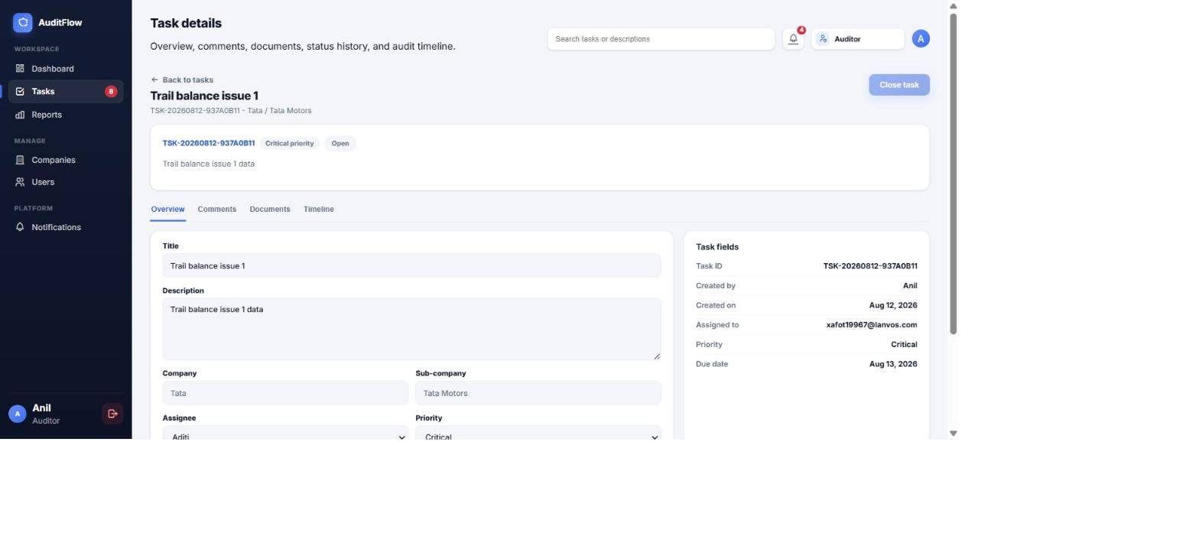
Figure 6 — task details, Overview tab
Field | Detail
Frontend route | /tasks/:taskId
Key endpoint(s) | GET /tasks/{id}; PUT /tasks/{id}; PATCH /tasks/{id}/status, /tasks/{id}/assign; POST/PUT/DELETE /tasks/{id}/comments[/{commentId}]; POST /files/upload, DELETE /tasks/{id}/attachments/{attachmentId}, GET /files/{fileId}
Primary DB table(s) | Tasks, Comments, Attachments, TaskStatusHistory, Notifications, AuditLogs
Note: Comment/attachment ownership: an Employee can only edit/delete their own comment or delete their own upload; Auditor/PlatformAdmin can moderate any (see TaskCommentCommandHandlers.cs / TaskAttachmentCommandHandlers.cs "isElevated" checks). PUT/DELETE .../comments/{commentId} were added 2026-08-14 — see §9.

4.7 Reports
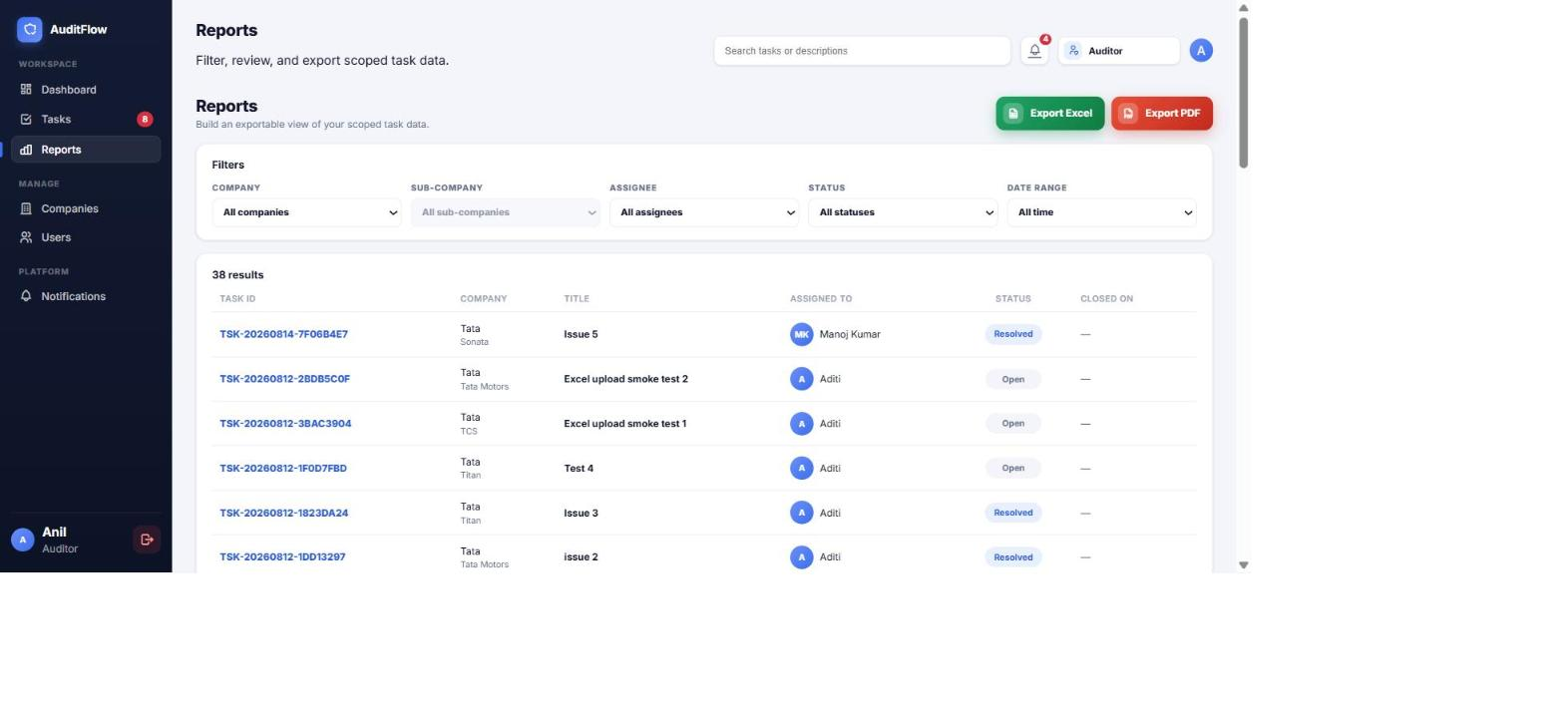
Figure 7 — Reports
Field | Detail
Frontend route | /reports
Key endpoint(s) | GET /reports/tasks, GET /reports/filter-options, GET /reports/tasks/export/{excel,pdf}, POST /reports/tasks/export/async, GET /reports/{id}, GET /reports/{id}/download
Primary DB table(s) | Tasks (via ReportPredicateBuilder — same ITenantScopeService scoping as everywhere else), Reports (async export queue), Attachments/FileStorage (generated file)
Note: Synchronous export caps at 10,000 rows (MaxSynchronousExportRows) — above that, /export/excel|pdf returns 400 EXPORT_TOO_LARGE and the frontend should fall back to the async /export/async flow, which runs as a Hangfire job and fires a ReportReady notification. Employee access to every reports/* endpoint was added 2026-08-14 (previously Auditor/CompanyAdmin only — a real gap, since the frontend already routed Employees here) — see §9.

4.8 Companies
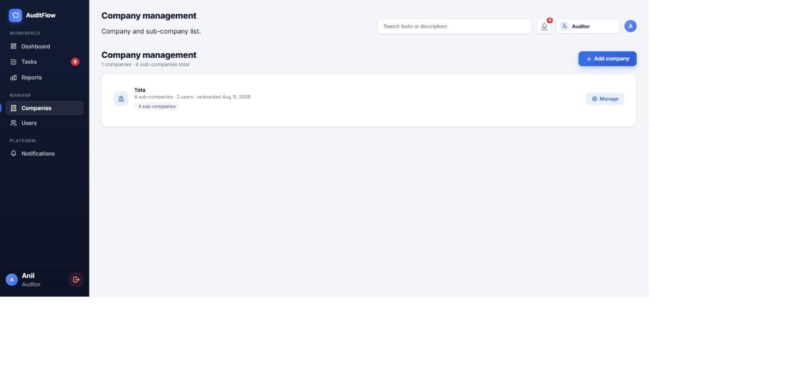
Figure 8 — Company management
Field | Detail
Frontend route | /companies
Key endpoint(s) | GET/POST/PUT/DELETE /companies, /companies/{id}/sub-companies
Primary DB table(s) | Companies, SubCompanies
Note: Auditor-only for writes. No bulk "replace all sub-companies" endpoint — the frontend diffs and calls add/update/delete individually per sub-company.

4.9 Users
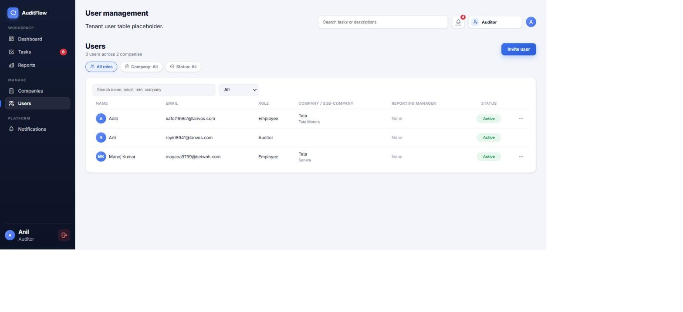
Figure 9 — User management
Field | Detail
Frontend route | /users
Key endpoint(s) | GET /users, POST /users/invite, PATCH /users/{id}/activate|deactivate, PUT /users/{id}
Primary DB table(s) | Users, Invitations, UserCompanyMappings (Auditor invites), AuditLogs
Note: InviteUserCommandHandler always maps an invited Auditor into UserCompanyMappings for the company chosen on the invite form — check that table first if a newly-invited Auditor reports they can't see the client they were meant to be scoped to.

4.10 Notifications
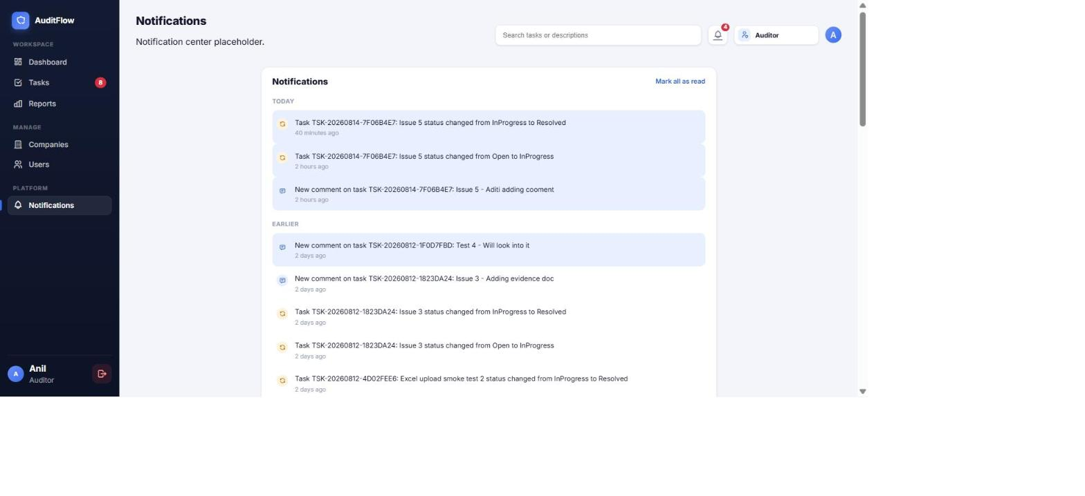
Figure 10 — Notifications
Field | Detail
Frontend route | /notifications
Key endpoint(s) | GET /notifications, PATCH /notifications/{id}/read, PATCH /notifications/read-all, DELETE /notifications/{id}
Primary DB table(s) | Notifications
Note: Instant emails only fire from a small set of Task events today (comment/assignment/status/report-ready) — most Task events surface as in-app notifications plus the once-daily digest job, not an instant email, unless the recipient has EmailNotificationsEnabled and DailyDigestEnabled=false.

4.11 Profile
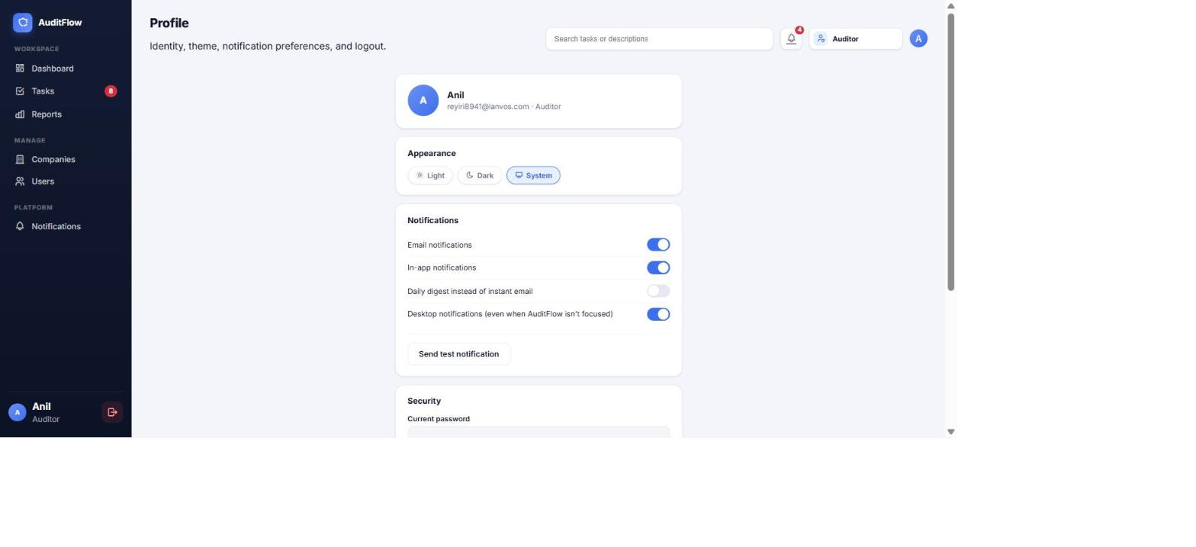
Figure 11 — Profile
Field | Detail
Frontend route | /profile
Key endpoint(s) | GET /users/me, PUT /users/me, PUT /users/me/notification-preferences, POST /auth/change-password, /auth/mfa/*
Primary DB table(s) | Users (Theme, EmailNotificationsEnabled, InAppNotificationsEnabled, DailyDigestEnabled, MfaEnabled/MfaSecret)

4.12 Platform admin — Auditor accounts / System overview / Audit log
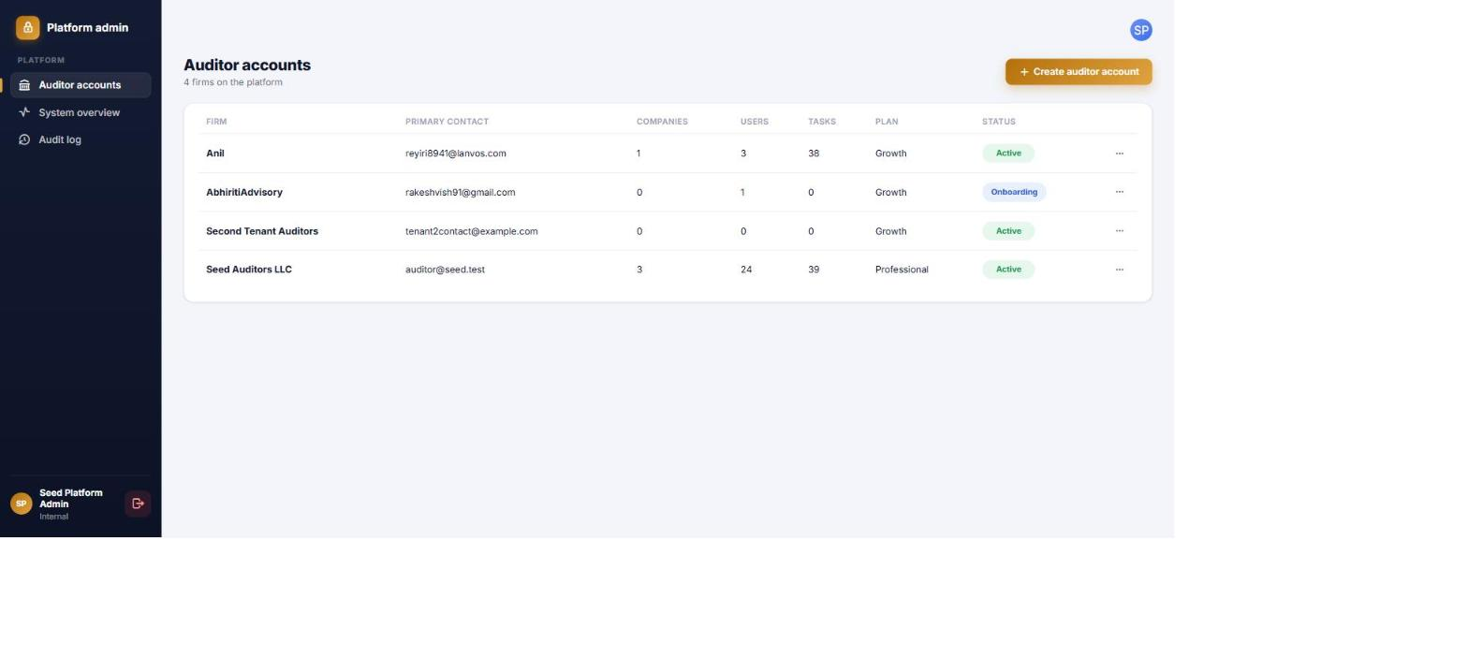
Figure 12 — Auditor accounts (tenant list)
Field | Detail
Frontend route | /admin/tenants, /admin/tenants/new, /admin/system, /admin/audit-log
Key endpoint(s) | GET/POST /admin/tenants, PATCH /admin/tenants/{id}/status, GET /admin/health, GET /admin/audit-log
Primary DB table(s) | Tenants, Companies/Users/Tasks (counts only, via .IgnoreQueryFilters()), AuditLogs
Note: Platform admin has TenantId = null, so the global tenant filter naturally returns zero tenant-scoped rows for every normal query — this is the actual enforcement of "zero access to audit content," not a UI-level restriction. Admin cross-tenant queries opt in explicitly via .IgnoreQueryFilters().

5. Database schema reference
Condensed from the backend repo's DatabaseStructure.md (generated from the actual EF Core entities/Fluent configurations, not a separate design doc). Every table listed inherits BaseEntity, so every table has IsDeleted/DeletedAt/DeletedBy/CreatedAt/UpdatedAt columns even where not called out below.

5.1 Tenancy & organization
Table | Key columns | Notes
Tenants | Name, Domain (unique), Plan (free text), Status (AuditorStatus), PrimaryContactEmail/Name | The root — called "Auditor Account" in the Admin API/UI
Companies | Name, Industry, TenantId (FK), Status (CompanyStatus) | Index (TenantId, Name)
SubCompanies | Name, CompanyId (FK), TenantId (denormalized copy of Company.TenantId), IsActive | TenantId is duplicated here purely so the global tenant filter has a column to filter on without an extra join

5.2 Identity & access
Table | Key columns | Notes
Users | FullName, Role (UserRole), Status (UserStatus), TenantId/CompanyId/SubCompanyId (nullable), ReportingManagerId (self-FK), MfaEnabled/MfaSecret, Theme, notification-preference flags | = ApplicationUser, extends IdentityUser<Guid>. Unique (TenantId, Email) filtered to IsDeleted=0
UserCompanyMappings | UserId, CompanyId, SubCompanyId (nullable), TenantId | Lets one Auditor be mapped across several companies at once. Unique (UserId, CompanyId, SubCompanyId)
Invitations | Email, FullName, Role, TenantId/CompanyId/SubCompanyId, Token, Status (InvitationStatus), InvitedByUserId, AcceptedByUserId
RefreshTokens | UserId, TokenHash (SHA-256 only — raw token never stored), ExpiresAt, RevokedAt, ReplacedByTokenHash | Unique index on TokenHash; (UserId, ExpiresAt) for bulk revoke on password change

5.3 Task management
Table | Key columns | Notes
Tasks (TaskItem) | TaskNumber (unique per TenantId), Title, Description, Status (AuditTaskStatus), Priority (TaskPriority), TenantId, CompanyId, SubCompanyId (nullable), AssignedToUserId/CreatedByUserId/ClosedByUserId, DueDate, ResolvedAt, ClosedAt | Full-text index (SQL Server, catalog AuditFlowFullTextCatalog) on Title+Description. See §9 for the 2026-08-14 index additions
TaskStatusHistories | TaskId, FromStatus, ToStatus, ChangedByUserId, Reason | Append-only, never soft-deleted — the immutable audit trail behind the Timeline tab
Comments | Content, TaskId, AuthorId, ParentCommentId (self-FK, one level of reply nesting), IsEdited/EditedAt | Index (TaskId, CreatedAt)
Attachments | FileName, ContentType, FileSize, StoragePath, StorageProvider, TaskId (nullable), CommentId (nullable), UploadedByUserId, Version/PreviousVersionId | Belongs to either a Task directly or a specific Comment (Comment→Attachment is Restrict, not Cascade, to avoid a multiple-cascade-path conflict since Task already cascades into Attachments directly)

5.4 Notifications, audit, reporting
Table | Key columns | Notes
Notifications | Title, Message, Type (NotificationType), Channel (NotificationChannel), UserId (recipient), TaskId (nullable, SetNull on task delete), CommentId/ActorUserId (nullable), IsRead/ReadAt | Index (UserId, IsRead, CreatedAt) for the unread-inbox query
Announcements | Title, Content, TenantId, StartsAt/ExpiresAt, IsPinned, TargetCompanyId (nullable = tenant-wide)
AuditLogs | EntityType/EntityId (polymorphic, no FK), Action (AuditAction), OldValuesJson/NewValuesJson/MetadataJson, UserId (SetNull), TenantId, IpAddress/UserAgent/CorrelationId | Never soft-deleted — the permanent compliance trail. Indexes on (EntityType,EntityId), (TenantId,CreatedAt), (UserId,CreatedAt), CorrelationId
Reports | Name, Type (ReportType), Format (ReportFormat), Status (ReportStatus), StoragePath, ParametersJson, RequestedByUserId, TenantId | Backs the async/queued export flow (Hangfire job) for exports over the sync row cap

5.5 Non-domain tables
Hangfire (SQL Server storage) creates its own Hangfire.*-schema tables (Job, JobParameter, JobQueue, Server, State, Set, Hash, Counter, ...) in the same database purely so the async report-export job has a queue to persist to — not part of the application's own domain model. __EFMigrationsHistory is EF Core's own bookkeeping of which migrations have run.

5.6 Enum reference (exact wire values)
Enum | Values
UserRole | PlatformAdmin=1, Auditor=2, CompanyAdmin=3, Employee=4
UserStatus | Invited=1, Active=2, Deactivated=3
AuditTaskStatus | Open=1, InProgress=2, Resolved=3, Closed=4, Reopened=5
TaskPriority | Low=1, Medium=2, High=3, Critical=4
CompanyStatus | Active=1, Inactive=2, Onboarding=3
InvitationStatus | Pending=1, Accepted=2, Expired=3, Revoked=4
NotificationType | TaskAssigned=1, TaskStatusChanged=2, TaskCommented=3, TaskReopened=4, TaskClosed=5, MentionedInComment=6, InvitationReceived=7, Announcement=8, ReportReady=9
NotificationChannel | InApp=1, Email=2, Both=3
FileStorageProvider | Local=1, AzureBlob=2, AwsS3=3
ReportFormat | Excel=1, Pdf=2
ReportType | TaskReport=1, UserActivityReport=2, CompanyPerformanceReport=3
ReportStatus | Pending=1, Generating=2, Completed=3, Failed=4
AuditorStatus | Onboarding=1, Active=2, Suspended=3, Cancelled=4
AuditAction | Created=1, Updated=2, Deleted=3, StatusChanged=4, Assigned=5, CommentAdded=6, AttachmentUploaded=7, AttachmentDeleted=8, UserInvited=9, UserActivated=10, UserDeactivated=11, CompanyCreated=12, CompanyUpdated=13, SubCompanyCreated=14, SubCompanyUpdated=15, BulkImport=16, Login=17, Logout=18, PasswordChanged=19, MfaEnabled=20, MfaDisabled=21, Impersonation=22
Note: "overdue" as seen in the frontend UI is not one of these — it's a synthetic, client-derived display status computed from Tasks.DueDate + the real AuditTaskStatus, never stored or sent as its own value.

5.7 Identity tables — a subtlety worth knowing
Because ApplicationDbContext extends IdentityDbContext, migrations also create AspNetRoles / AspNetUserRoles / AspNetUserClaims / AspNetUserLogins / AspNetUserTokens / AspNetRoleClaims. Users.Role (the plain int column) is what every [Authorize(Roles="...")] check and handler-level role check reads day-to-day — but at login, LoginCommandHandler builds the JWT's role claim from UserManager.GetRolesAsync(user), i.e. from AspNetUserRoles, only falling back to Users.Role.ToString() if that comes back empty. Both are written together whenever a role is set, so they normally agree — but if you're debugging a JWT with an unexpected/missing role claim, check AspNetUserRoles first, not just Users.Role.

5.8 Current migration history
Migration | What it added
20260723154423_InitialCreate | Original schema: Tenants, Companies, SubCompanies, Users, Tasks, Comments, Attachments, TaskStatusHistories, Notifications, AuditLogs, Invitations, Announcements, RefreshTokens
20260723161027_AddTenantIsolationAndUserCompanyMapping | TenantId columns backing the global tenant filter, plus UserCompanyMappings
20260723214338_AddReports | The Reports table (async/queued export flow)
20260724065057_AddTaskListIndexAndFullTextSearch | (CompanyId, Status, CreatedAt) composite index on Tasks; SQL Server full-text catalog/index over Tasks.Title/Description
20260804154753_MakeInvitationCompanyIdNullable | Invitations.CompanyId made nullable
20260810155348_AddPushSubscriptionsAndPushPreference | Push-notification subscription support
20260812182601_AddIsInitialUploadToAttachments | Attachments.IsInitialUpload — distinguishes evidence attached at task creation from evidence added later via the Documents tab
20260814080730_AddExecutiveDashboardIndexes | (TenantId,Status,DueDate), (TenantId,Priority,CreatedAt), (TenantId,ClosedByUserId,Status) on Tasks — see §9

6. Common troubleshooting queries
Run against the local AuditFlow database (sqlcmd -S localhost -d AuditFlow -E -C -Q "...", or SSMS/Azure Data Studio).

Find a user and confirm their role/status/tenant
SELECT Id, Email, FullName, Role, Status, TenantId, CompanyId, SubCompanyId, MfaEnabled, LastLoginAt
FROM Users WHERE Email = 'someone@example.com';
-- Role: 1=PlatformAdmin 2=Auditor 3=CompanyAdmin 4=Employee
-- Status: 1=Invited 2=Active 3=Deactivated

Which companies is an Auditor actually mapped to?
SELECT m.CompanyId, c.Name, m.SubCompanyId
FROM UserCompanyMappings m JOIN Companies c ON c.Id = m.CompanyId
WHERE m.UserId = (SELECT Id FROM Users WHERE Email = 'auditor@example.com');
-- Zero rows = unmapped Auditor = unrestricted within their tenant (not "sees nothing")

Find all tasks for a company or an assignee
SELECT TaskNumber, Title, Status, Priority, DueDate, AssignedToUserId, CreatedAt
FROM Tasks WHERE CompanyId = '<company-guid>' AND IsDeleted = 0
ORDER BY CreatedAt DESC;

Why did a report export fail or never complete?
SELECT Name, Format, Status, TotalRecords, ErrorMessage, CreatedAt, CompletedAt
FROM Reports WHERE RequestedByUserId = (SELECT Id FROM Users WHERE Email = 'someone@example.com')
ORDER BY CreatedAt DESC;
-- Status: 1=Pending 2=Generating 3=Completed 4=Failed -- check ErrorMessage on a Failed row

Recent audit trail for a specific task or user
SELECT TOP 50 Action, EntityType, EntityId, UserId, CreatedAt, MetadataJson
FROM AuditLogs WHERE EntityId = '<task-guid>' ORDER BY CreatedAt DESC;
SELECT TOP 50 Action, EntityType, CreatedAt FROM AuditLogs
WHERE UserId = (SELECT Id FROM Users WHERE Email = 'someone@example.com')
ORDER BY CreatedAt DESC;

A task's full status history (mirrors the Timeline tab)
SELECT FromStatus, ToStatus, ChangedByUserId, Reason, CreatedAt
FROM TaskStatusHistories WHERE TaskId = '<task-guid>' ORDER BY CreatedAt;

Check a user's active sessions
SELECT Id, ExpiresAt, RevokedAt, ReplacedByTokenHash FROM RefreshTokens
WHERE UserId = (SELECT Id FROM Users WHERE Email = 'someone@example.com')
ORDER BY CreatedAt DESC;
-- RevokedAt IS NULL and ExpiresAt in the future = a live session

Unread notification count for a user (what the bell badge shows)
SELECT COUNT(*) FROM Notifications
WHERE UserId = (SELECT Id FROM Users WHERE Email = 'someone@example.com')
AND IsRead = 0 AND IsDeleted = 0;

"Why is this Employee getting 403 Forbidden on a page they should have access to?"
Check the controller's [Authorize(Roles="...")] attribute for that endpoint first — the frontend route being reachable doesn't guarantee the backend endpoint allows the role (see §9 for a real example: Reports was Auditor/CompanyAdmin-only on the backend for months after the frontend already routed Employees there). If the role list is correct, the underlying query handler almost certainly already scopes correctly via ITenantScopeService — the fix in that situation is adding the missing role to the attribute, not touching the query logic.

7. Background jobs & where things run
- Hangfire (SQL Server storage, same AuditFlow database) runs the async report-export job and the daily-digest notification job. No Hangfire dashboard UI is wired into this app — job state lives purely in the Hangfire.* tables (query Hangfire.Job / Hangfire.State directly if a queued report never seems to complete).
- Report generation: a request to POST /reports/tasks/export/async creates a Reports row (Status=Pending) and enqueues IReportGenerationJob via IReportExportQueue — the job re-runs the same ReportPredicateBuilder-scoped query, writes the file to storage, flips Status to Completed/Failed, and fires a ReportReady notification.
- Excel export uses ClosedXML; PDF export uses QuestPDF (both already in the stack, not something to add).
- Dev email: every "sent" email lands in C:\AuditFlow\EmailPickup\ as an .html file instead of going out over real SMTP — check there before assuming an email genuinely failed to send.

8. Logs
- Backend structured logs (Serilog) → C:\AuditFlow\Logs\ — includes request logging, the LoggingBehavior/PerformanceBehavior pipeline output (a >500ms handler logs a warning here), and unhandled exceptions from GlobalExceptionHandlingMiddleware.
- Frontend: no server-side log file — check the browser console/network tab, or the corresponding backend request in the Serilog file (correlate via the ApiResponse envelope's correlationId, which also appears in AuditLogs.CorrelationId).
- A 401/403 straight from [Authorize] (wrong/missing role, expired token) returns an empty body — it never reaches a handler and won't have a correlationId to chase; check the JWT's role/exp claims (jwt.io) first in that case.

9. Recent changes (this engagement)
Dated so this stays useful as a changelog, not just a snapshot — most recent first.
Date | Change
2026-08-14 | Executive dashboard: added Priority mix, Overdue aging, Reviewer performance, Net backlog movement, and an On-time closure KPI — all backed by new/extended backend endpoints (GET /dashboard/executive/{aging,reviewer-performance}, ExecutiveKpisResponse.OnTimeClosureRate).
2026-08-14 | Added 3 Tasks indexes: (TenantId,Status,DueDate), (TenantId,Priority,CreatedAt), (TenantId,ClosedByUserId,Status) — migration AddExecutiveDashboardIndexes. Purely additive, nothing dropped.
2026-08-14 | Fixed GetTrendDataAsync's per-day query loop (up to ~90 sequential round trips for a 90-day range) into 2 GROUP BY queries — same output, far fewer round trips.
2026-08-14 | Added 60s IMemoryCache to all 8 executive/* dashboard queries (previously uncached, recomputed every request). In-process only — won't share cache hits across horizontally-scaled API instances; no write-path invalidation, so a task edit can take up to 60s to show up here (same tradeoff as the pre-existing ComputeTaskStatisticsAsync cache).
2026-08-14 | "Highest-risk tasks" widget now uses the exact same at-risk definition (overdue OR due within 7 days, date-range/status/company-scoped) as the At-risk KPI card above it — previously used an unrelated overdue-OR-Critical-priority definition with no date scoping, so the two numbers could visibly disagree.
2026-08-14 | Executive dashboard KPI cards, status-mix legend, and risk-task rows are now clickable — deep-link to /tasks/all?status=X, same mechanism the Standard dashboard's cards already used. Added an "At risk" pseudo-status to the Tasks grid (client-filtered, same treatment as the existing "Overdue" one) so the At-risk card has somewhere correct to land.
2026-08-14 | Fixed: Employee role got 403 Forbidden on every /reports/* endpoint. ReportsController was [Authorize(Roles="Auditor,CompanyAdmin")] on all 8 actions even though the frontend has always routed Employees to /reports and every underlying query handler already scopes correctly via ITenantScopeService. Added Employee to the role list on all 8 endpoints.
2026-08-14 | Comments/Documents on a task: delete/edit icons are now owner-scoped (an Employee only sees them on their own comment/upload; Auditor/PlatformAdmin can moderate anyone's, matching the backend's existing isElevated logic). Added the previously-missing PUT/DELETE /tasks/{id}/comments/{commentId} endpoints — the handlers already existed but had no route wired to them.

10. Known gaps (production-readiness, not "unbuilt")
All 10 functional modules are wired end-to-end and live-tested against a real database — this is not early-stage stub code. What's actually left, from the backend repo's AuditSummary.md §13 (re-verify there for the current, authoritative list):
- No real secrets for a Production environment (deliberately blank — must come from env vars/Key Vault); no CI/CD or Dockerfile; dead disabled auto-migrate code in Program.cs should be deleted; AuditLog/TaskStatusHistory soft-delete exclusion isn't cleanly implemented.
- Admin health endpoint's lastBackupAt is a placeholder (databaseSizeBytes/version/environment are real and live-queried); instant emails only fire from a subset of Task events, not every one — most rely on the daily digest instead.
- No automated cross-tenant isolation tests confirmed at time of writing (CrossTenantIsolationIntegrationTests.cs may already exist — verify before assuming this is a gap).
- No MFA / global-exception-middleware test coverage; bulk import is CSV-only despite ClosedXML already being a dependency; no self-service full-name edit.
- Redis connection string is configured but unused anywhere — the executive dashboard's new caching (see §9) is in-process IMemoryCache, not Redis, so it won't share hits across more than one API instance.

